**NAME: AADITYA PARTIBAN**

**REG.NO: 192211037**

**Day-1**

**Q.1) Write a LEX program to identify the capital words from the given input.**

**CODE:**

%%

[A-Z]+[\t\n ] { printf("%s is a capital word\n",yytext); }

.  ;

%%

int main( )

{

printf("Enter String :\n");

yylex();

}

int yywrap( )

{

return 1;

}

**Output:**

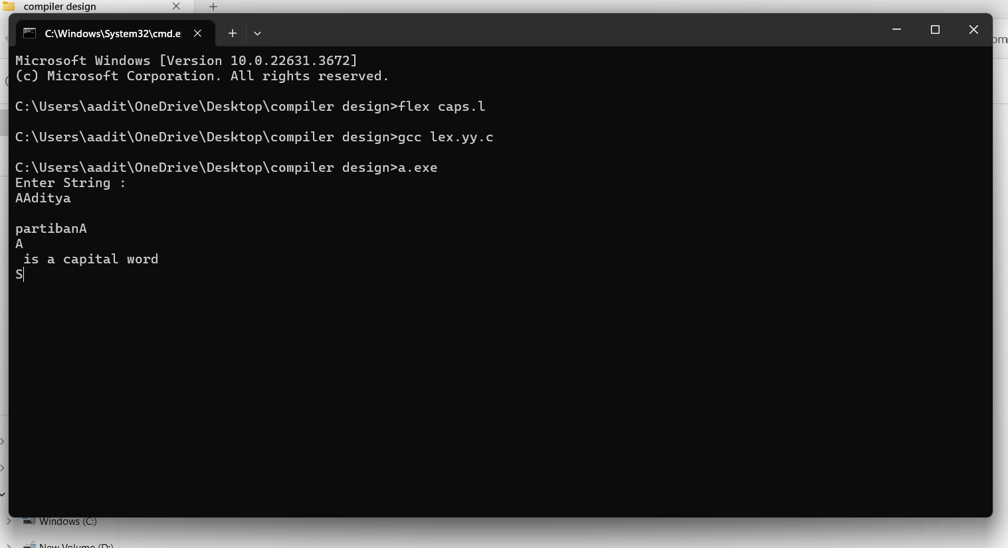

Q2.) Write a LEX program to check whether the given input is digit or not.

CODE:

%%

[0-9]+ {printf("\nValid digit \n");}

.* printf("\nInvalid digit\n");

%%

int yywrap(){}

int main()

{

yylex();

return 0;

}

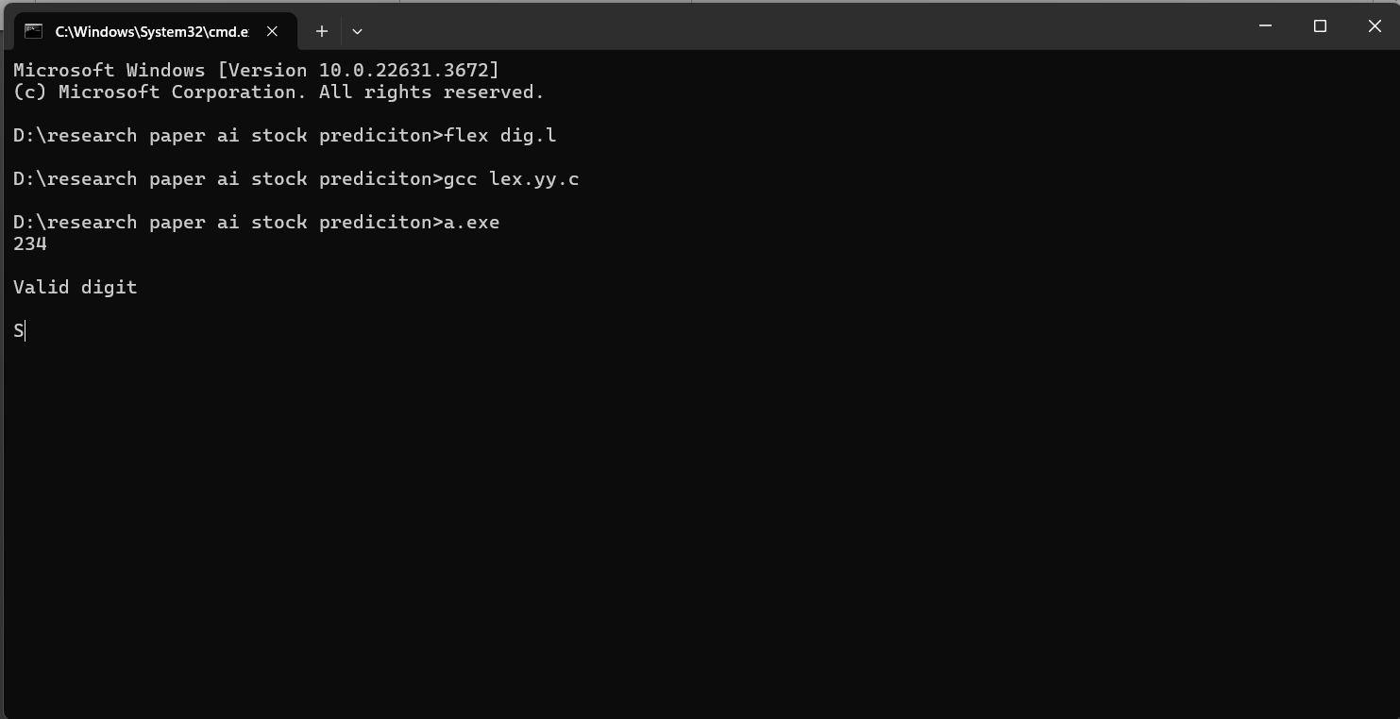

Q3.) LEX program to check whether the mobile number is valid or not.

Code:

%%

[1-9][0-9]{9} {printf("\nMobile Number Valid\n");}

.+ {printf("\nMobile Number Invalid\n");}

%%

int main()

{

printf("\nEnter Mobile Number : ");

yylex();

printf("\n");

return 0;

}

int yywrap()

{ }

Output:

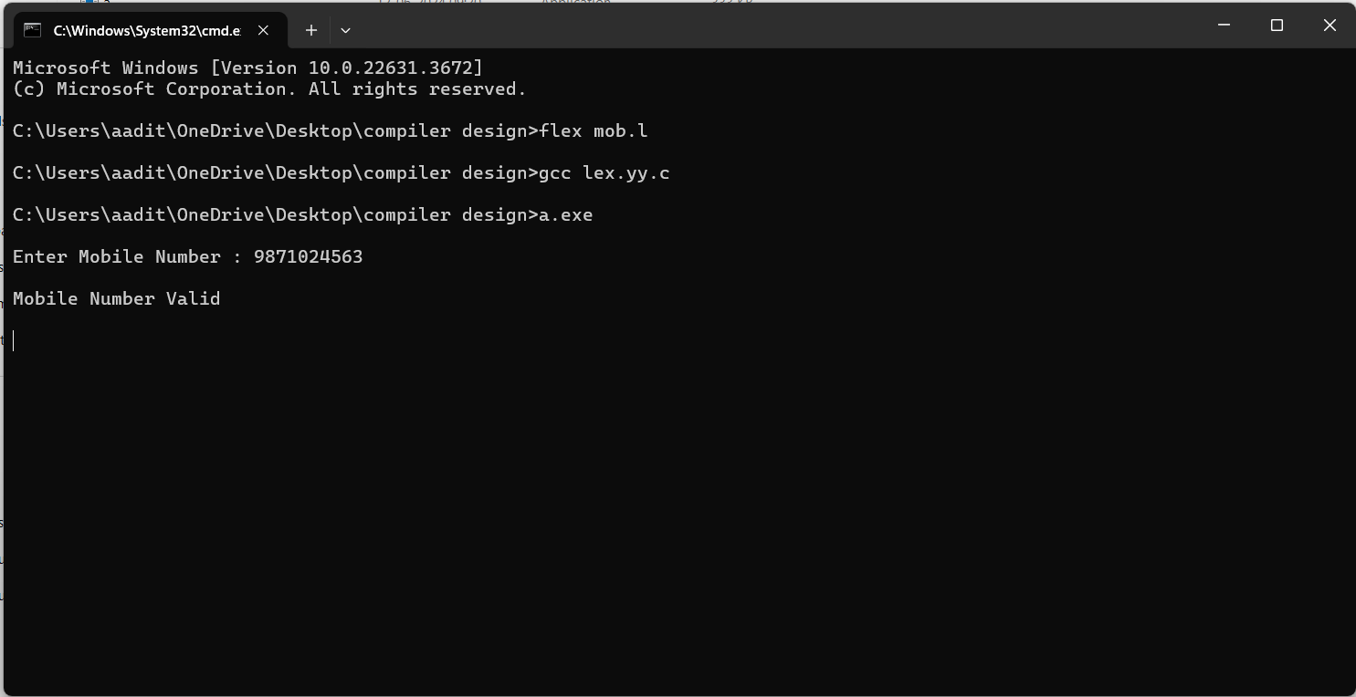

Q4.) Write an algorithm to help the student to count the number of vowels and consonants in the given sentence

Code:

%{

    int vow_count=0;

    int const_count =0;

%}

%%

[aeiouAEIOU] {vow_count++;}

[a-zA-Z] {const_count++;}

%%

int yywrap(){}

int main()

{

    printf("Enter the string of vowels and consonants:");

    yylex();

    printf("Number of vowels are:  %d\n", vow_count);

    printf("Number of consonants are:  %d\n", const_count);

    return 0;

}

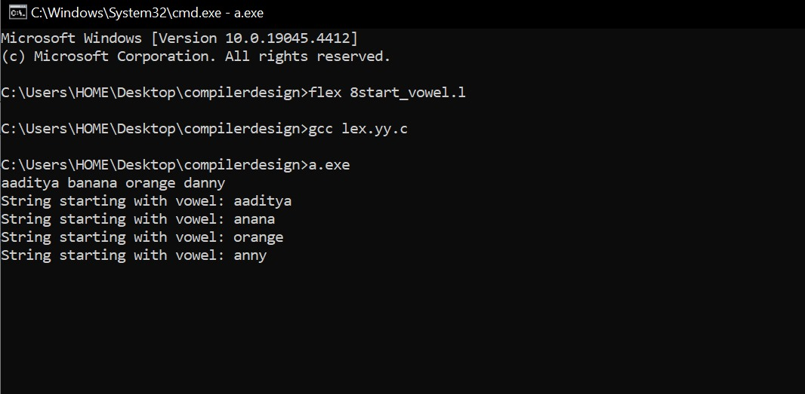

Q5.) write a LEX program to separate keywords and identifiers.

Code:

digit [0-9]

letter [A-Za-z]

%{

int count_id,count_key;

%}

%%

(stdio.h|conio.h) { printf("%s is a standard library\n",yytext); }

(include|void|main|printf|int) { printf("%s is a keyword\n",yytext); count_key++; }

{letter}({letter}|{digit})* { printf("%s is a identifier\n", yytext); count_id++; }

{digit}+ { printf("%s is a number\n", yytext); }

\"(\\.|[^"\\])*\" { printf("%s is a string literal\n", yytext); }

.|\n { }

%%

int yywrap(void) {

return 1;

}

int main(int argc, char *argv[]) {

yyin = fopen(argv[1], "r");

yylex();

printf("number of identifiers = %d\n", count_id);

printf("number of keywords = %d\n", count_key);

fclose(yyin);

}

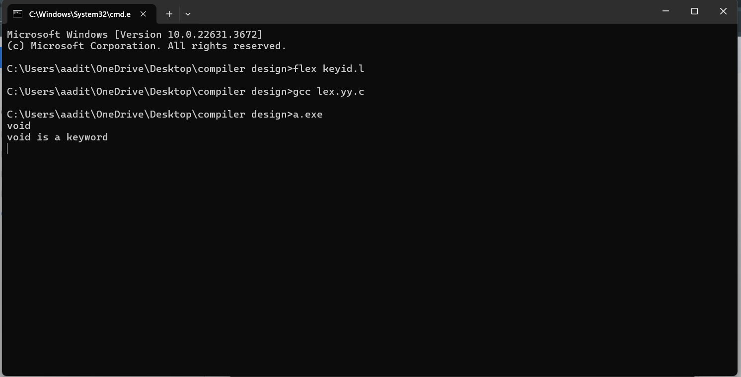

Q6.) Write a LEX program to identify and count positive and negative numbers.

Code: %{

int positive_no = 0, negative_no = 0;

%}

%%

^[-][0-9]+ {negative_no++;

printf("negative number = %s\n",

yytext);} // negative number

[0-9]+ {positive_no++;

printf("positive number = %s\n",

yytext);} // positive number

%%

int yywrap(){}

int main()

{

yylex();

printf ("number of positive numbers = %d,"

"number of negative numbers = %d\n",

positive_no, negative_no);

return 0;

}

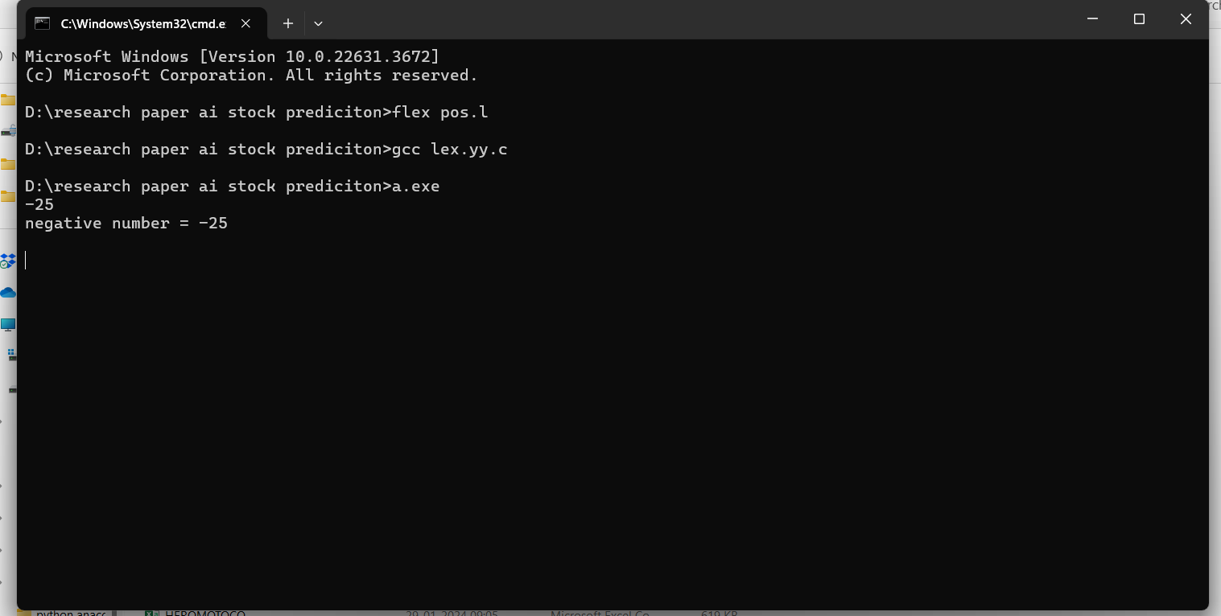

Q7.) Write a LEX program to recognise numbers and words in a statement.

Code:

%%

[\t ]+ ;

[0-9]+|[0-9]*\.[0-9]+ { printf("\n%s is NUMBER", yytext);}

#.* { printf("\n%s is COMMENT", yytext);}

[a-zA-Z]+ { printf("\n%s is WORD", yytext);}

\n { ECHO;}

%%

int main()

{

while( yylex());

}

int yywrap( )

{

return 1;

}

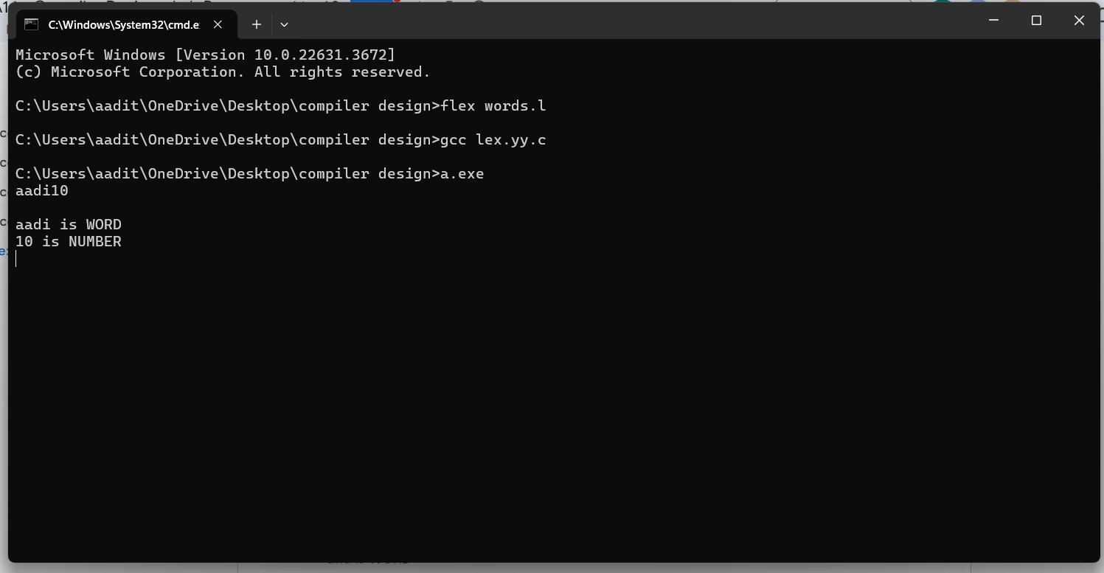

Q8.) Write a LEX program to accept string starting with vowel.

Code: %{

#include <stdio.h>

%}

%%

[AEIOUaeiou][a-zA-Z]* { printf("String starting with vowel: %s\n", yytext); }

.|\n { /* Ignore other characters */ }

%%

int main() {

yylex();

return 0;

}

int yywrap() {

return 1;

}

